|  |
| --- |
| HelloFresh® - Canada's #1 Meal Kit Delivery Service |
| HelloFresh Database Project  DBS 211 Project  Group 9 & 10 |
| |  |  |  | | --- | --- | --- | | Submitted by Jubin Verma (Leader) | 11/28/24 | Submitted to Lydia li | |



|  |  |  |  |
| --- | --- | --- | --- |
| Names | Student ID | Oracle ID | Seneca Email |
| Jubin Verma | 153629233 | DBS211_243NBB40 | Jverma22@myseneca.ca |
| Abhinav kushwaha | 123812232 | dbs211_243nbb15 | akushwaha3@myseneca.ca |
| Photswat Boonmee | 147840235 | dbs211_243nbb04 | pboonmee@myseneca.ca |
| Susinta Bastola | 116376245 | dbs211_243nbb02 | sbastola6@myseneca.ca |
| Liang Yu Wang | 147528236 | dbs211_241zbb40:43021967 | lywang8@myseneca.ca |
| Sandhya Timsina | 169206232 | dbs211_243nbb32 | Stimsina2@myseneca.ca |



HelloFresh is a global meal-kit delivery service that provides fresh, pre-portioned ingredients and easy-to-follow recipes to customers’ doorsteps. As the meal-kit industry has seen significant growth in recent years, HelloFresh has become a leader in the sector by catering to diverse dietary preferences and busy lifestyles. The group selected this topic because of the rising popularity of subscription-based food delivery services and the necessity of maintaining efficient database systems to support operations. This project seeks to explore how HelloFresh's extensive data management requirements can be addressed through a tailored database solution.

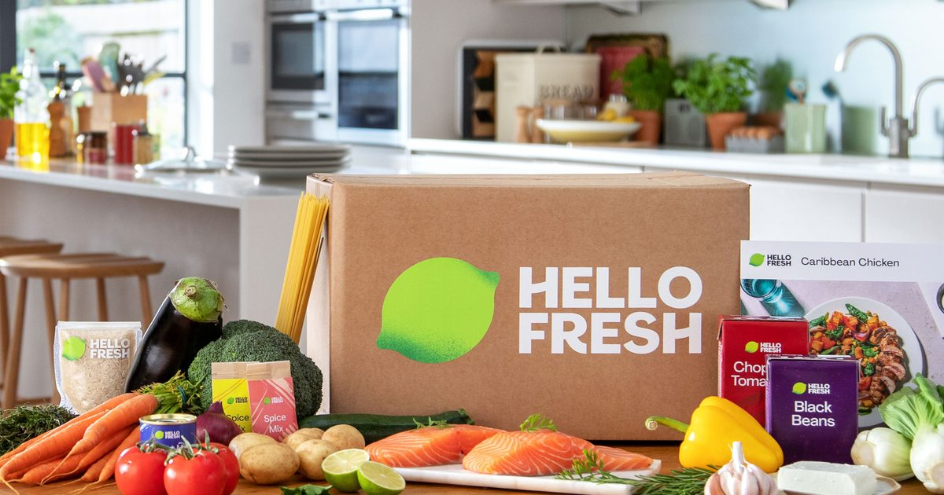



The meal-kit delivery industry requires efficient systems to track customer preferences, manage inventory, and ensure timely deliveries. Without a robust database, HelloFresh would struggle to manage its vast network of customers, ingredients, recipes, and suppliers, leading to inefficiencies in operations. The need for a database for the complexity of data storage, retrieval, and reporting for business decision-making.



The team will develop a relational database to support HelloFresh’s operations, enabling the company to manage customer orders, track inventory levels, monitor supplier data, and generate insightful business reports. This database will streamline operations, enhance customer satisfaction, and provide actionable insights for business growth. The solution will also focus on scalability to adapt to HelloFresh's expansion.



**Database Requirements:**

* **User Login/Registration:**
  + **H_EMPLOYEE: Store employee credentials for login access.**
  + **H_CUSTOMER: Store customer login details and registration information.**
* **Customer Profiles:**
  + **H_CUSTOMER: Store customer preferences, allergies, and delivery addresses.**
  + **H_SUBSCRIPTION: Store subscription details, including plan types and status.**
* **Inventory Levels:**
  + **H_INGREDIENT: Track available stock levels of ingredients to prevent shortages.**
* **Orders and Deliveries:**
  + **H_CUSTOMERORDERS: Store and track customer orders, payment status, and delivery schedules.**
  + **H_DELIVERY: Track delivery details, delivery status, and associated orders.**
* **Meal Ratings:**
  + **H_REVIEW: Store customer reviews and ratings for meals.**

**Reporting Requirements:**

* **Revenue Tracking:**
  + **H_PAYMENT: Generate reports on revenue, payment status, and transactions.**
* **Customer Retention:**
  + **H_SUBSCRIPTION: Track customer subscription statuses, cancellations, and renewal rates.**
* **Ingredient Usage:**
  + **H_INGREDIENT: Track frequently used ingredients and generate reports on ingredient stock levels.**
* **Delivery Performance:**
  + **H_DELIVERY: Monitor and report on delivery performance, including on-time deliveries and delays.**

**User Requirements:**

1. **Account Management**:
   * Customers and employees can register and log in. Data stored in **H_CUSTOMER** and **H_EMPLOYEE**.
2. **Profile Management**:
   * Customers manage personal info, preferences, and subscription details in **H_CUSTOMER** and **H_SUBSCRIPTION**.
3. **Order & Delivery Tracking**:
   * Track orders and delivery statuses, stored in **H_CUSTOMERORDERS** and **H_DELIVERY**.
4. **Meal Ratings & Feedback**:
   * Customers can rate meals and leave feedback, stored in **H_REVIEW**.
5. **Payment Processing**:
   * Secure payment transactions tracked in **H_PAYMENT**.
6. **Favorites & Recipe Management**:
   * Customers can save favorite recipes, managed in **H_RECIPE** and **H_CUSTOMER**.
7. **Promotions & Discounts**:
   * Notify customers of discounts and offers via **H_SUBSCRIPTION** and **H_CUSTOMERORDERS**.



**H_CUSTOMER**

| **Column** | **Data Type** | **Size, Precision** | **Default** | **PK/FK** | **Required** | **Range** | **Sample Data** | **Notes** |
| --- | --- | --- | --- | --- | --- | --- | --- | --- |
| CustomerID | NUMBER | 4 |  | PK | Y | 1-9999 | 1023 | Unique customer ID |
| firstName | VARCHAR | 50 |  |  | Y |  | John | Customer first name |
| lastName | VARCHAR | 50 |  |  | Y |  | Doe | Customer last name |
| email | VARCHAR | 100 |  |  | Y |  | john@example.com | Customer email address |
| phone | VARCHAR | 15 |  |  | Y |  | 9055551212 | Customer phone number |
| address | VARCHAR | 200 |  |  | Y |  | 123 Elm St | Customer address |
| registrationDate | DATE |  |  |  | Y |  | 2023-01-15 | Date of registration |

| **Column** | **Data Type** | **Size, Precision** | **Default** | **PK/FK** | **Required** | **Range** | **Sample Data** | **Notes** |
| --- | --- | --- | --- | --- | --- | --- | --- | --- |
| OrderID | NUMBER | 4 |  | PK | Y | 1-9999 | 1001 | Unique order ID |
| CustomerID | NUMBER | 4 |  | FK | Y | 1-9999 | 1023 | Reference to customer |
| OrderDate | DATE |  |  |  | Y |  | 2023-02-01 | Date of order |
| TotalAmount | NUMBER | 8,2 | 0.00 |  | Y |  | 49.99 | Total order amount |
| OrderStatus | VARCHAR | 20 |  |  | Y |  | 'Delivered' | Order status |

**H_CUSTOMERORDER**

**H_DELIVERY**

| **Column** | **Data Type** | **Size, Precision** | **Default** | **PK/FK** | **Required** | **Range** | **Sample Data** | **Notes** |
| --- | --- | --- | --- | --- | --- | --- | --- | --- |
| DeliveryID | NUMBER | 4 |  | PK | Y | 1-9999 | 5001 | Unique delivery ID |
| OrderID | NUMBER | 4 |  | FK | Y | 1-9999 | 1001 | Linked to order |
| DeliveryDate | DATE |  |  |  | Y |  | 2023-02-05 | Date of delivery |
| DeliveryTime | VARCHAR | 5 |  |  | Y |  | '14:30' | Delivery time |
| DeliveryStatus | VARCHAR | 20 |  |  | Y |  | 'Delivered' | Delivery status |

| **Column** | **Data Type** | **Size, Precision** | **Default** | **PK/FK** | **Required** | **Range** | **Sample Data** | **Notes** |
| --- | --- | --- | --- | --- | --- | --- | --- | --- |
| EmployeeID | NUMBER | 4 |  | PK | Y | 1-9999 | 201 | Unique employee ID |
| firstName | VARCHAR | 50 |  |  | Y |  | Jane | Employee first name |
| lastName | VARCHAR | 50 |  |  | Y |  | Smith | Employee last name |
| jobTitle | VARCHAR | 50 |  |  | Y |  | 'Delivery Driver' | Employee job title |
| phone | VARCHAR | 15 |  |  | Y |  | 9055551234 | Employee phone number |

**H_EMPLOYEE**

**H_INGREDIENT**

| **Column** | **Data Type** | **Size, Precision** | **Default** | **PK/FK** | **Required** | **Range** | **Sample Data** | **Notes** |
| --- | --- | --- | --- | --- | --- | --- | --- | --- |
| IngredientID | NUMBER | 4 |  | PK | Y | 1-9999 | 301 | Unique ingredient ID |
| name | VARCHAR | 100 |  |  | Y |  | 'Tomato' | Ingredient name |
| quantityInStock | NUMBER | 8,2 | 0.00 |  | Y |  | 150.00 | Quantity in stock |
| unit | VARCHAR | 20 |  |  | Y |  | 'kg' | Unit of measurement |

**H_MEALPLAN**

| **Column** | **Data Type** | **Size, Precision** | **Default** | **PK/FK** | **Required** | **Range** | **Sample Data** | **Notes** |
| --- | --- | --- | --- | --- | --- | --- | --- | --- |
| MealPlanID | NUMBER | 4 |  | PK | Y | 1-9999 | 101 | Unique meal plan ID |
| CustomerID | NUMBER | 4 |  | FK | Y | 1-9999 | 1023 | Linked to customer |
| PlanDate | DATE |  |  |  | Y |  | 2023-02-10 | Date of meal plan |

**H_PAYMENT**

| **Column** | **Data Type** | **Size, Precision** | **Default** | **PK/FK** | **Required** | **Range** | **Sample Data** | **Notes** |
| --- | --- | --- | --- | --- | --- | --- | --- | --- |
| PaymentID | NUMBER | 4 |  | PK | Y | 1-9999 | 4001 | Unique payment ID |
| OrderID | NUMBER | 4 |  | FK | Y | 1-9999 | 1001 | Linked to order |
| PaymentDate | DATE |  |  |  | Y |  | 2023-02-01 | Date of payment |
| Amount | NUMBER | 8,2 |  |  | Y |  | 49.99 | Payment amount |

**H_RECIPE**

| **Column** | **Data Type** | **Size, Precision** | **Default** | **PK/FK** | **Required** | **Range** | **Sample Data** | **Notes** |
| --- | --- | --- | --- | --- | --- | --- | --- | --- |
| RecipeID | NUMBER | 4 |  | PK | Y | 1-9999 | 901 | Unique recipe ID |
| name | VARCHAR | 100 |  |  | Y |  | 'Pasta' | Recipe name |
| ingredients | VARCHAR | 255 |  |  | Y |  | 'Tomato, Cheese' | Ingredients list |
| instructions | TEXT |  |  |  | Y |  | 'Boil pasta, mix ingredients' | Recipe instructions |

**H_REVIEW**

| **Column** | **Data Type** | **Size, Precision** | **Default** | **PK/FK** | **Required** | **Range** | **Sample Data** | **Notes** |
| --- | --- | --- | --- | --- | --- | --- | --- | --- |
| ReviewID | NUMBER | 4 |  | PK | Y | 1-9999 | 1501 | Unique review ID |
| RecipeID | NUMBER | 4 |  | FK | Y | 1-9999 | 901 | Linked to recipe |
| CustomerID | NUMBER | 4 |  | FK | Y | 1-9999 | 1023 | Linked to customer |
| Rating | NUMBER | 1 |  |  | Y | 1-5 | 4 | Rating out of 5 |
| Comments | TEXT |  |  |  | N |  | 'Great taste' | Review comments |

**H_SUBSCRIPTION**

| **Column** | **Data Type** | **Size, Precision** | **Default** | **PK/FK** | **Required** | **Range** | **Sample Data** | **Notes** |
| --- | --- | --- | --- | --- | --- | --- | --- | --- |
| SubscriptionID | NUMBER | 4 |  | PK | Y | 1-9999 | 601 | Unique subscription ID |
| CustomerID | NUMBER | 4 |  | FK | Y | 1-9999 | 1023 | Linked to customer |
| StartDate | DATE |  |  |  | Y |  | 2023-01-01 | Subscription start date |
| EndDate | DATE |  |  |  | Y |  | 2023-12-31 | Subscription end date |
| Status | VARCHAR | 20 |  |  | Y |  | 'Active' | Subscription status |